1. **PURPOSE:**

To provide a procedure For Operation and calibration of Agilent 1260 infinity series HPLC.

1. **SCOPE:**

This procedure is applicable to the HPLC following in Quality Control laboratory.

**Make**  : Agilent Technologies

**Model** : 1260 infinity series

**Instrument** **ID No.** : DIPL/QC/INS/HPLC/004.

1. **RESPONSIBILITY:**
   1. Analyst-QC shall be responsible to follow this SOP.
   2. Head-QC/Designee shall be responsible for ensuring implementation of this SOP.
   3. Head-QA/Designee shall be responsible for monitoring overall compliance of this SOP.
2. **DEFINITIONS:**

Nil

1. **PROCEDURE:**
   1. **Operation:**
      1. Check that the instrument is clean and free from dust, if not clean with a soft cloth duster
   2. The LC-1260 infinity series HPLC work station consist of :
      1. Quaternary pump
      2. Thermostat Ted column compartment
      3. Auto Sampler
      4. Variable wavelength detector
      5. Computer with windows based HPLC Openlab-Ezchrome elite software
   3. **Basic Operation**
      1. Ensure that the system is connected to stabilized power supply.
      2. Put on the main switch of the instrument. Identify the column to be used for analysis enter the column details in to the edit column.
      3. Connect the prescribed column in the right direction; connect the tubing from the injector to one end of the column and other end to the tugging towards the detector.
   4. **Creating initial admin user:**
      1. 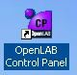 Double click on the **Openlab control panel**.
      2. Click Administration in the navigation pane and select System Configuration.

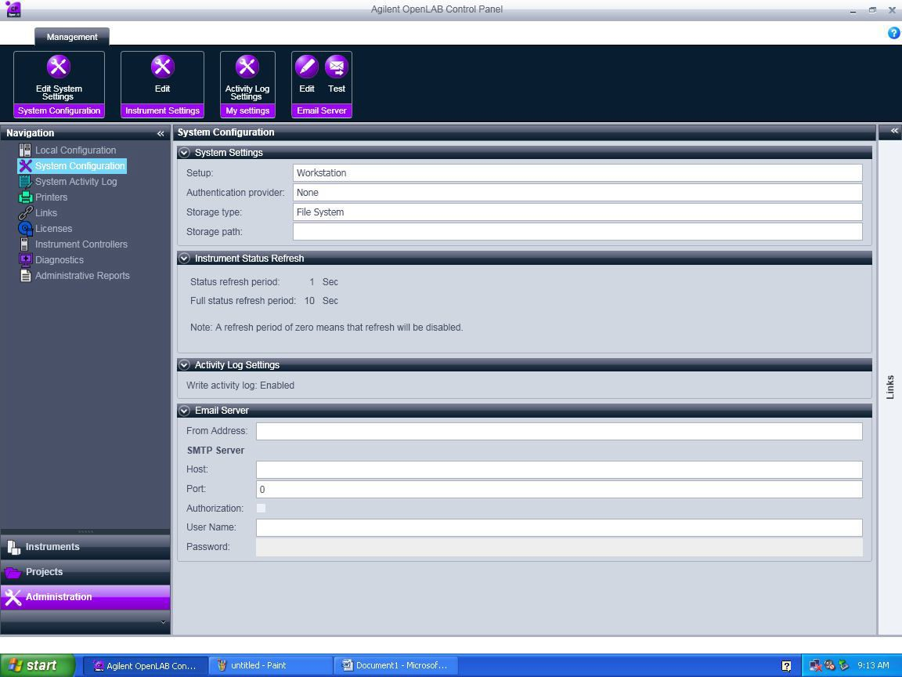

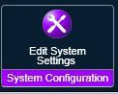Click on Edit system settings

* + 1. The below screen will appear. In the first scroll bar select internal and click Next

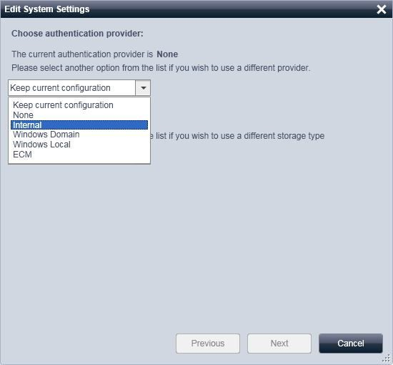

* + 1. The below screen appear. Click on Create Account.

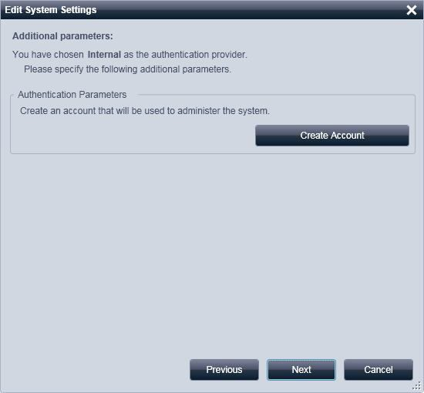

* + 1. Create Administrator Account window will appear. Enter User Name, Full Name, Password and confirm Password details and click OK. ( ** Note: Initial Admin user is must to enable security policy’s and user creation options in the control panel)

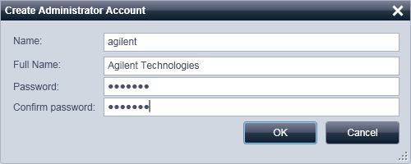

* + 1. Below screen will appear. Click Next

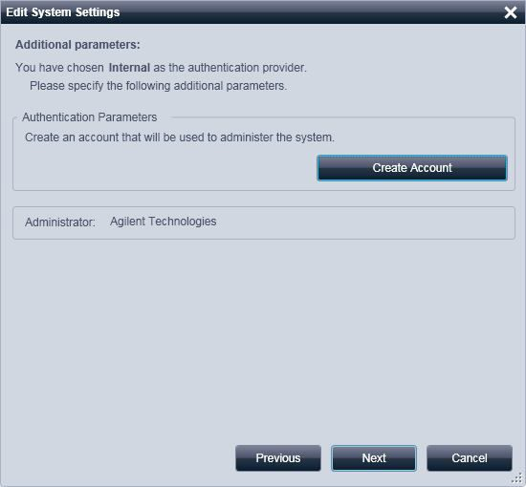

* + 1. Below screen will appear. Click on apply and OK in the next screen, it will close and restart the control panel with user credential options.

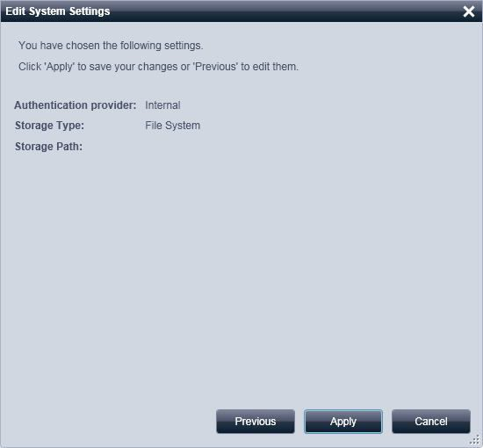

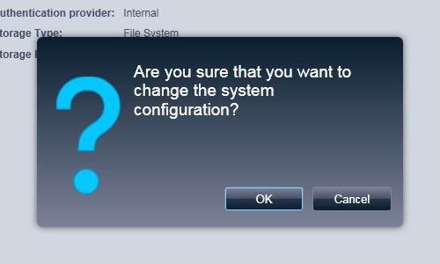

* + 1. Enter the created Admin user and password and click OK.

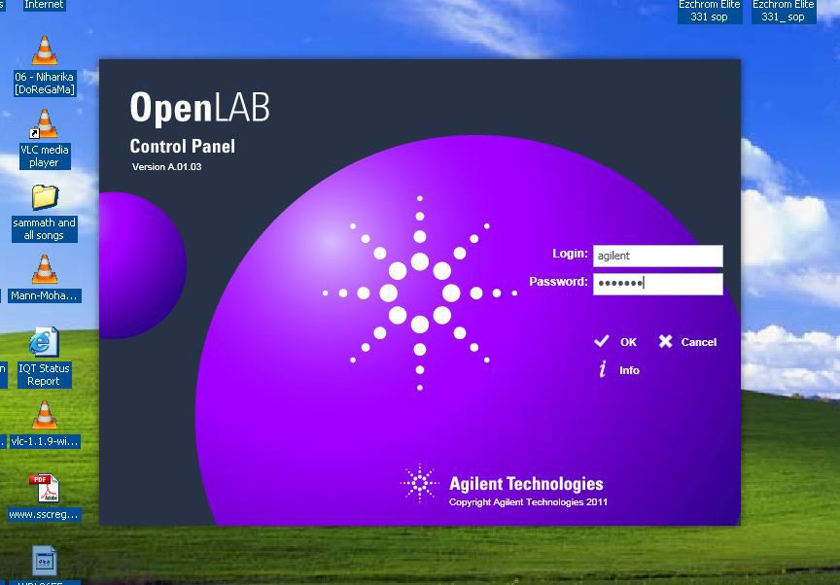

* + 1. Control Panel window will open with enabled Security policy and users Options

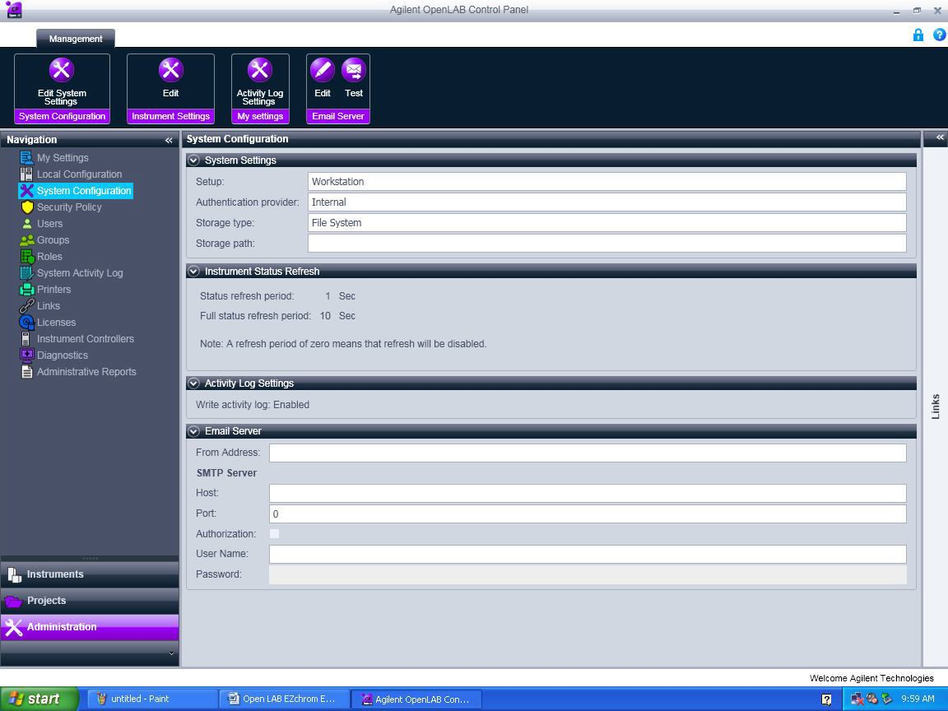

* + 1. Click Administration -> Security Policy -> Click Edit  and edit Minimum password length and Password expiration period (days) if required.
    2. To create users click Administration and click on users -> click create  and follow the screen.

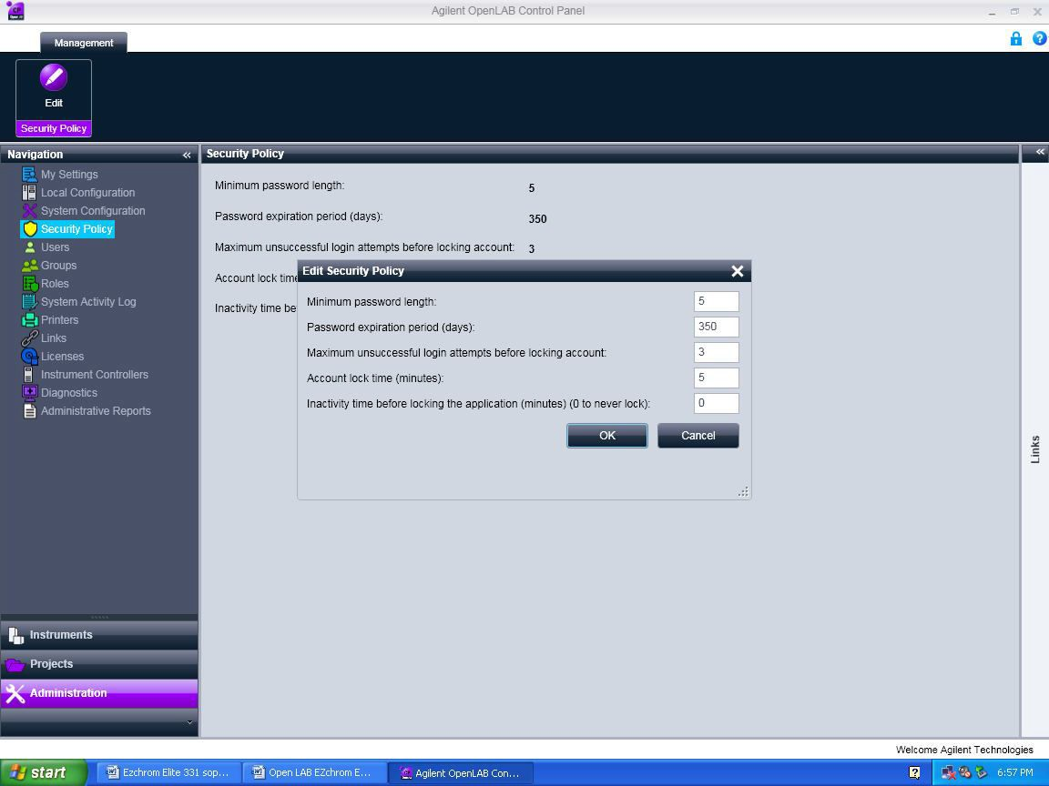

* 1. **Creating data storage path**
     1. Create a Data folder (EX: “Projects” folder or “EZDATA” folder) in C drive or D drive.
     2. In Administration pane click on System Configuration -> Edit System setting and in the second scroll window select File System and click Next.

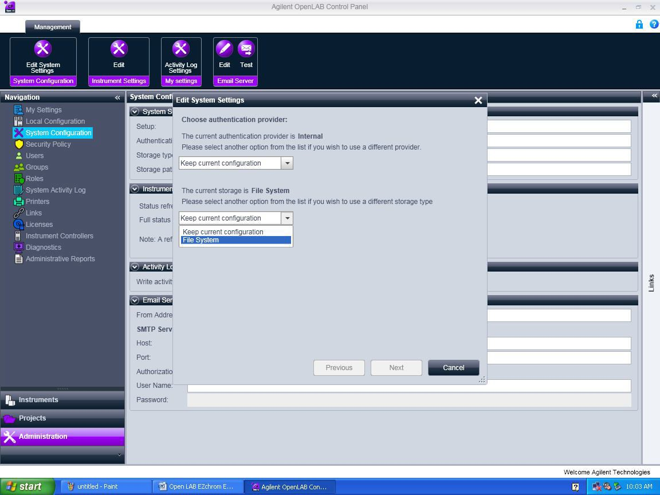

* + 1. The below screen will appear. Browse the data folder (Ex: projects folder) which is already created in the C drive or D drive. Select the created folder and click OK.

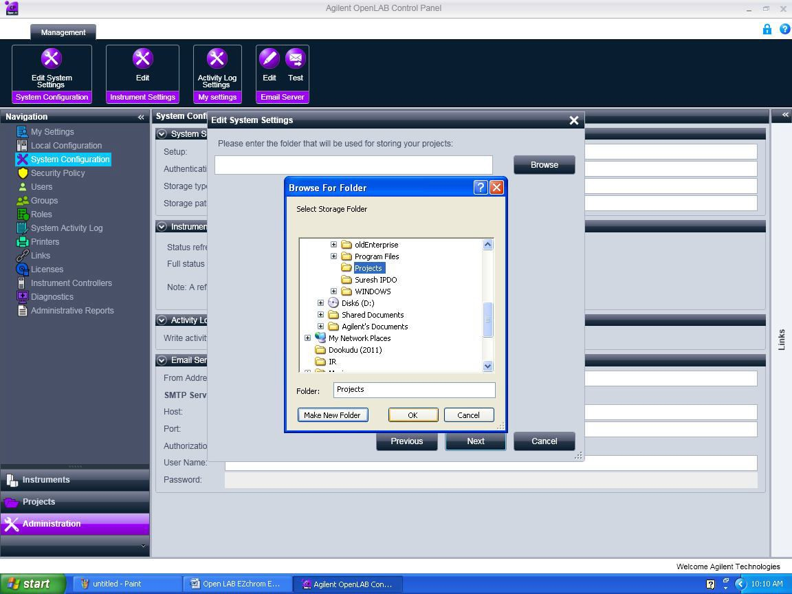

* + 1. Below screen will appear. Click on Next and Apply in the next screen and click OK in the following window. It will close and restart the control panel.

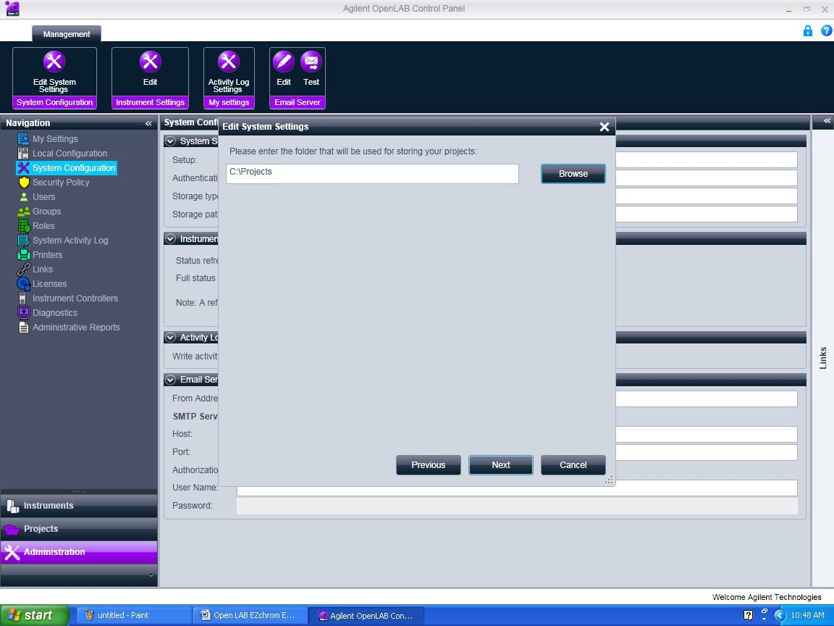



* 1. **How to Crate Project:**
     1. Click on Projects in the navigation pane and click on Create  -> click on Create Project.

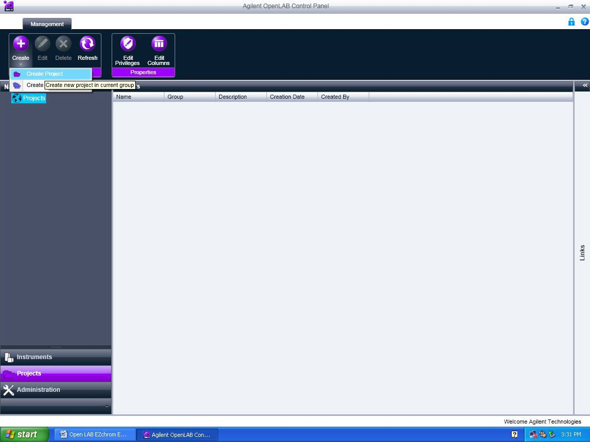

* + 1. In the below screen enter Project Name (Ex. Demo) and project Description -> Click on EZChrom.

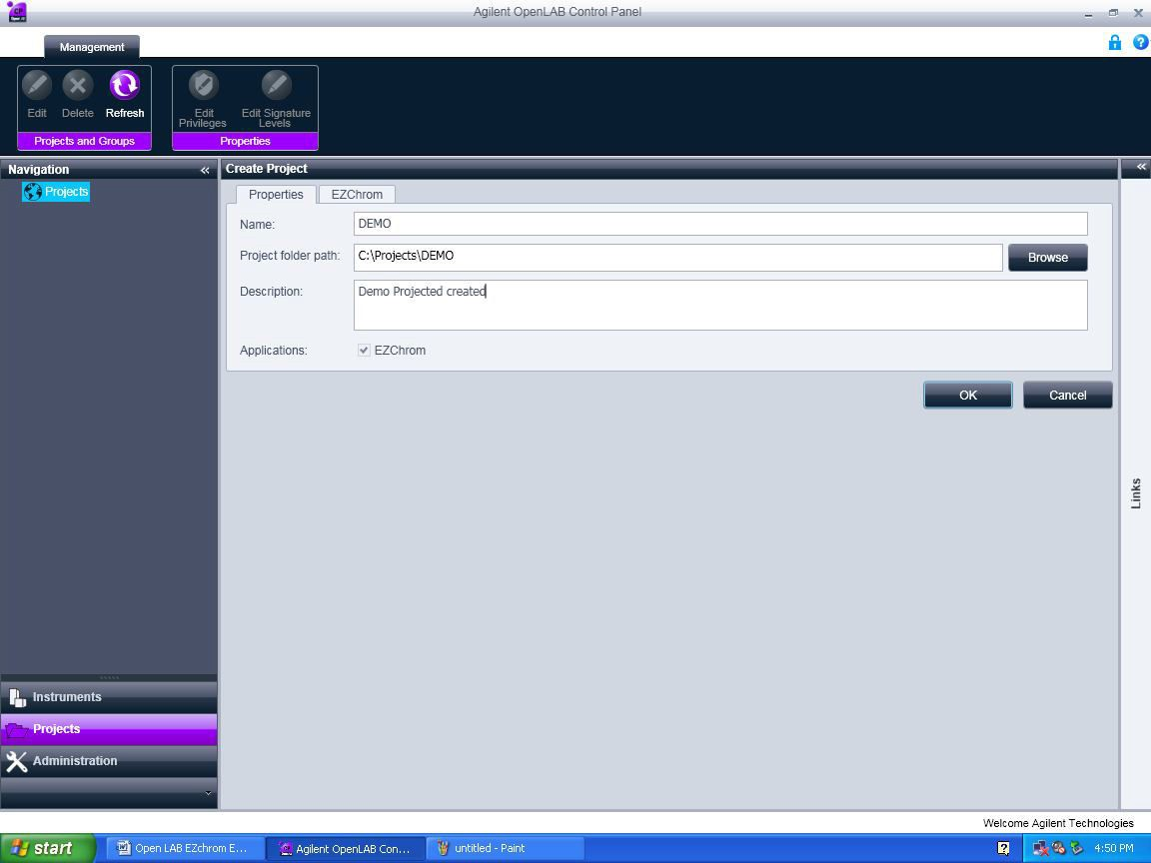

* + 1. The below screen will appear. In Project Options Select the checkboxes for Save all analysis result in data file.
    2. In Result Set Mode select Result Package Mode and select the below two options as shown in the screen shot.
  + Include Method and Sample Prep files in Result Package.
  + Include Report Template files in Result Package.

**\*\* *Don’t Select the Update Original Methods during acquisition with analysis updates***

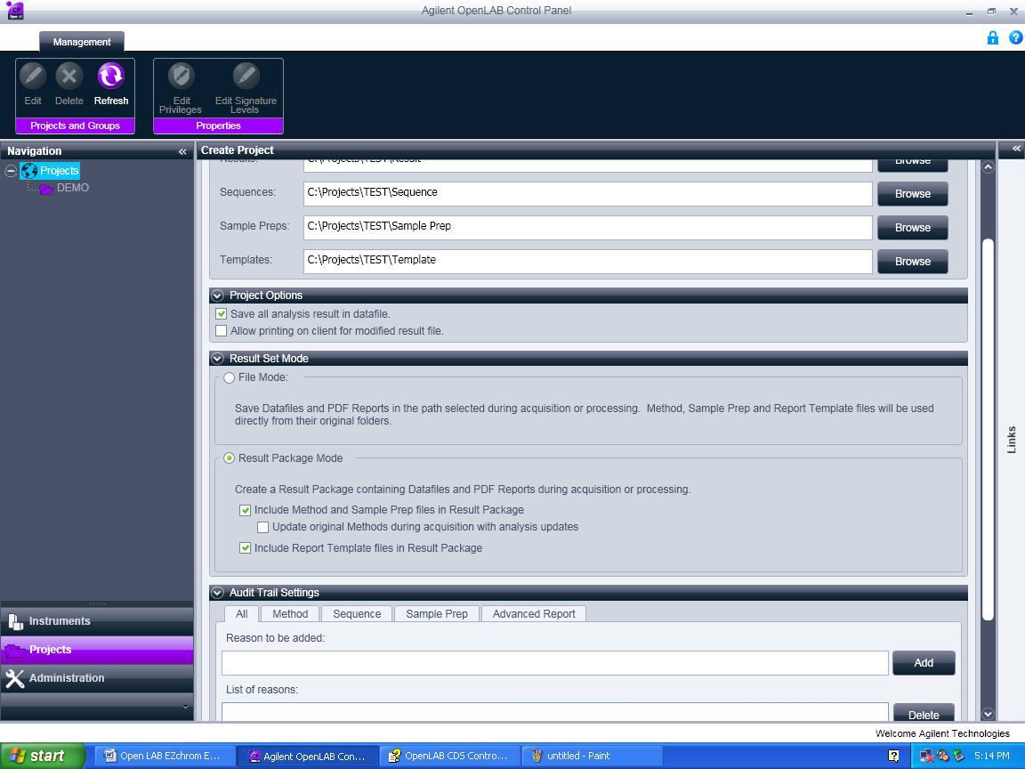

* + 1. Enable Audit Trials in the Audit Trial Setting window. When finished click Ok.

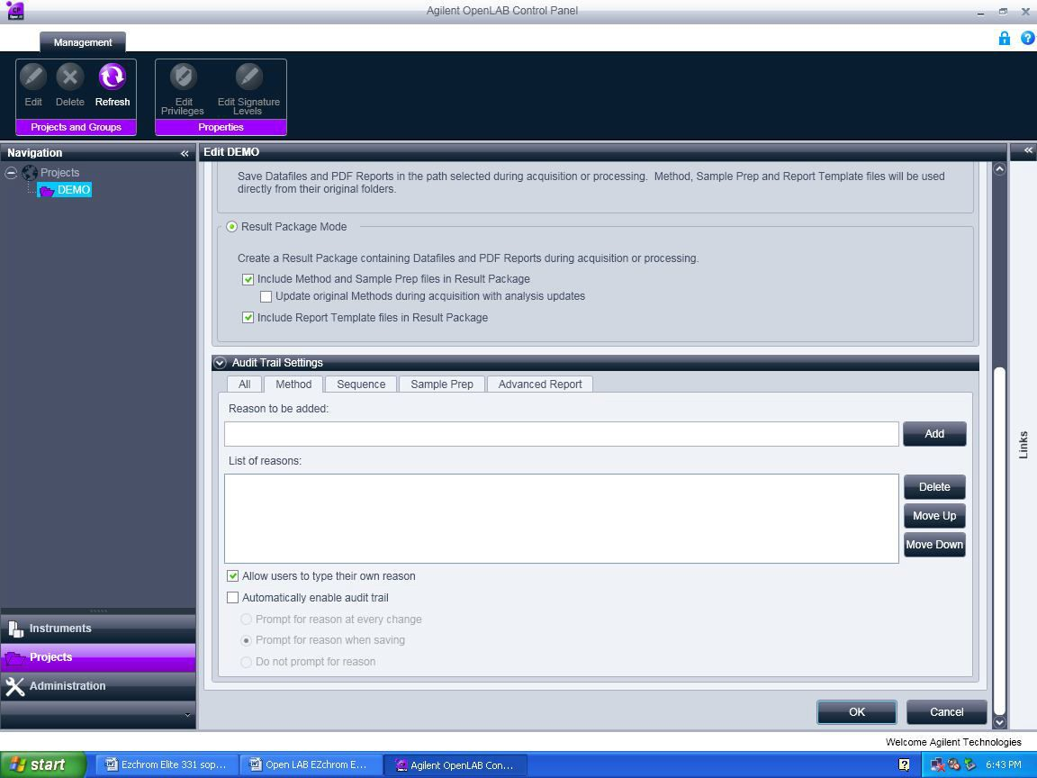

* 1. **Create Method** 
     1. Double click on the Open LAB Control Panel icon. 
     2. Enter the Use ID and Password and click ok.

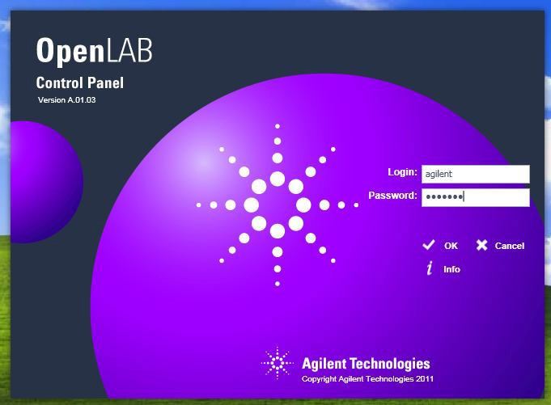

* + 1. Select the Instrument (HPLC) in the navigation (instruments) pane and browse to select the required project and click Launch for online and Launch offline for offline.

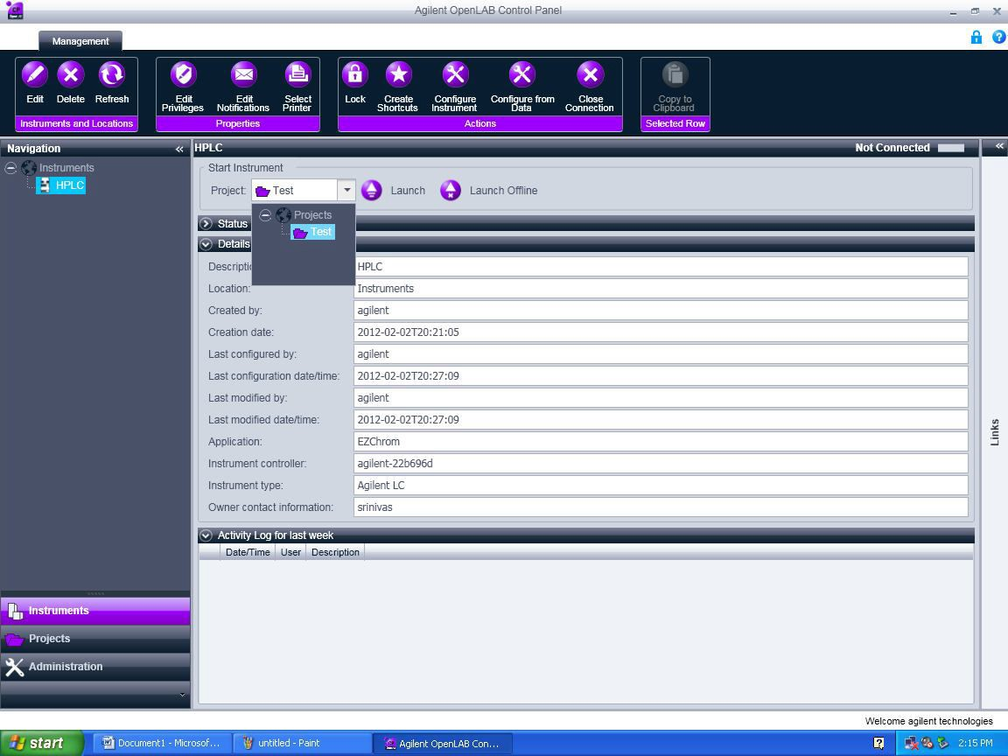

* + 1. Close the instrument wizard window.

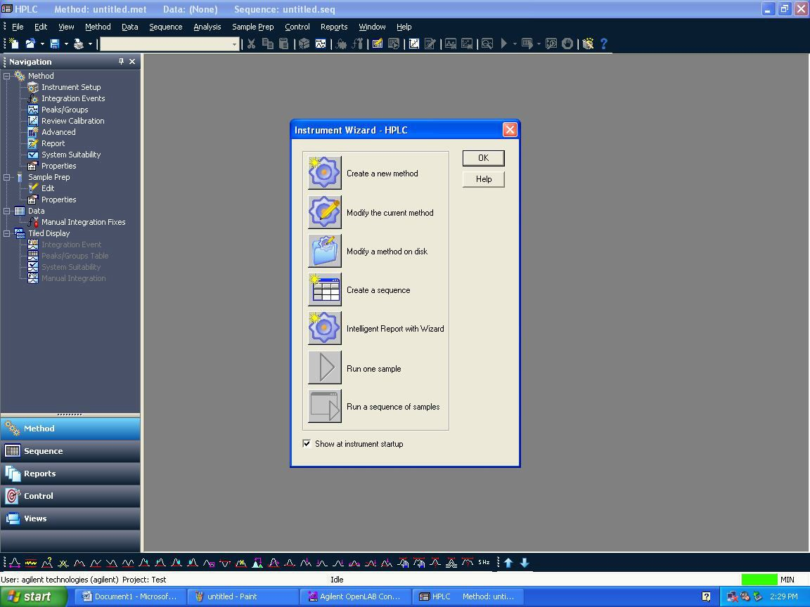

* + 1. Click file > New > and select Blank.met in New file Template and click ok. It will load the Instrument setup window

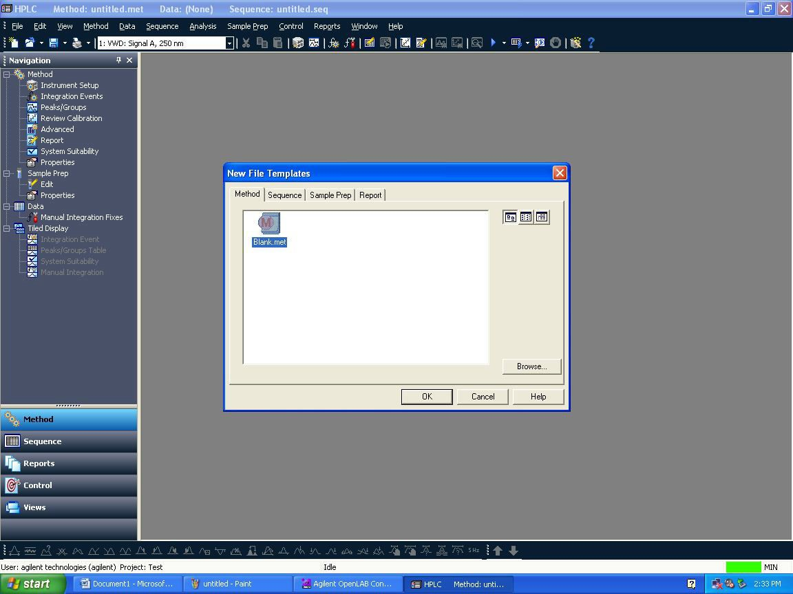

* + 1. Select each module and enter the method parameters as per method spec.
* **Detector:**

Enter wavelength nm – Peak width 0.1 - stop time should be as Pump/ injector.

* **Column Comp:**

Enter the temperature in the Left and select combined in the Right – stop time should be as Pump/ Injector.

* **Quat. Pump:**

Enter flow rate and select the initial solvent composition ( B or C or D) in the solvents – Enter the stop time in the pump. In the right side Timetable check the function centric view box and change the Gradient compositions.

* **Trigger:**

It should be external always.

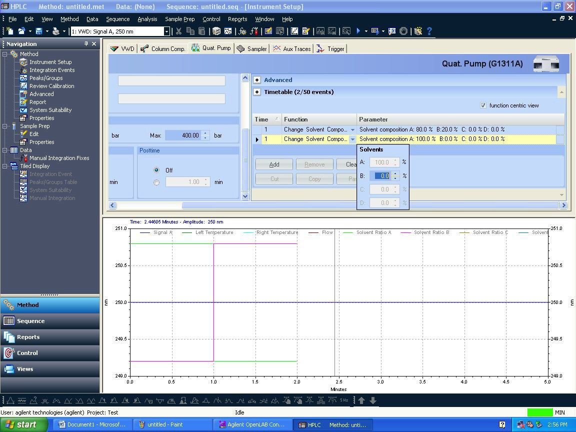

* + 1. After editing all the method parameters, you need to save the method by clicking File-> Save As-> Method

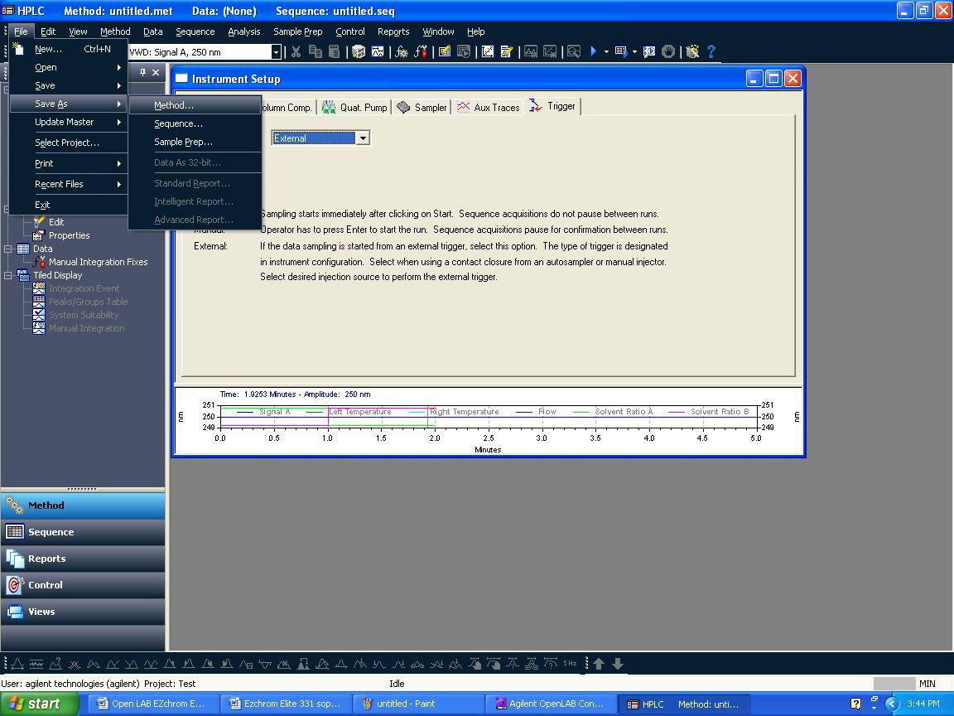

* + 1. Save method screen will appear. Give Method file name in blank space and click save.

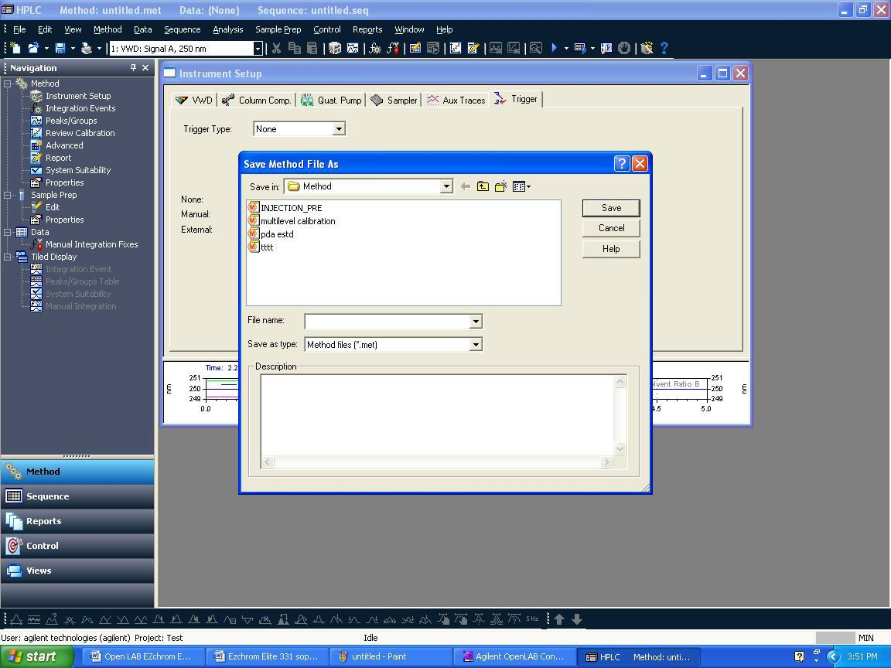

* + 1. After saving method file, down load it into instrument by clicking Control →Download method

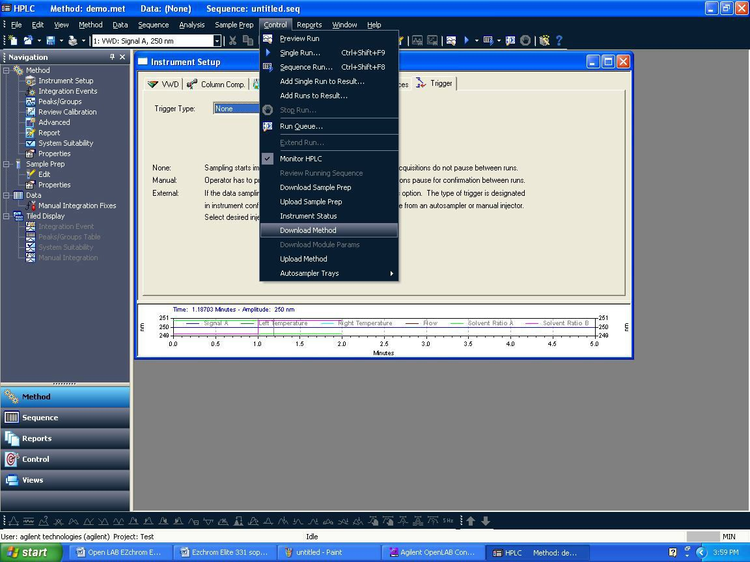

* + 1. After downloading the method, you can see online signal before injection i.e. to check baseline gets stabilize or not. Click On View →Online signal.

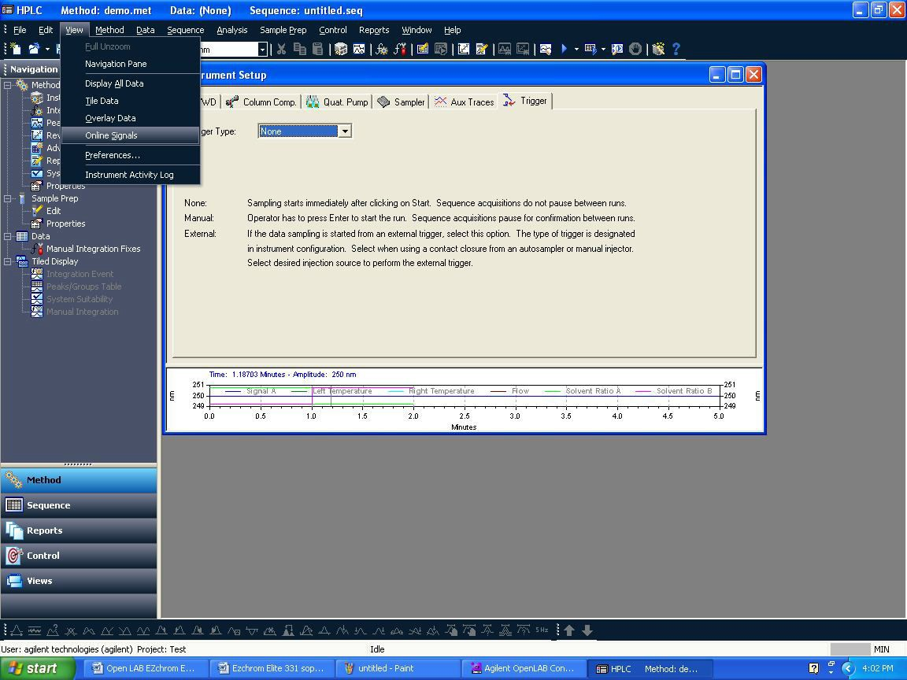

* 1. **How to do single run acquisition:**
     1. Click on Control→Single Run. One window will appear and in that need to enter sample ID, Data file name, Result set name, Vial number and injection volume.

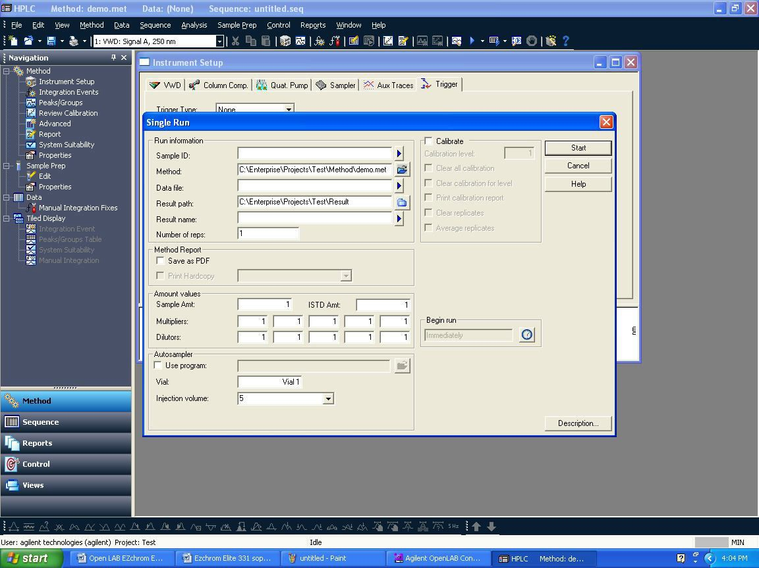

* + 1. Enter sample ID, Data path (browse your path if required), Data file name. In Sample ID and Data file name by clicking triangle symbol , you will be able to give different styles of naming sample ID and data file. Here let select **Increment number**. Give Number of unknown runs in sequence (i.e.: no. of lines you want to create in sequence, for exp. give: 10). Also you can give repetitions per run.
    2. After filling detail in below window, click on **Next.**

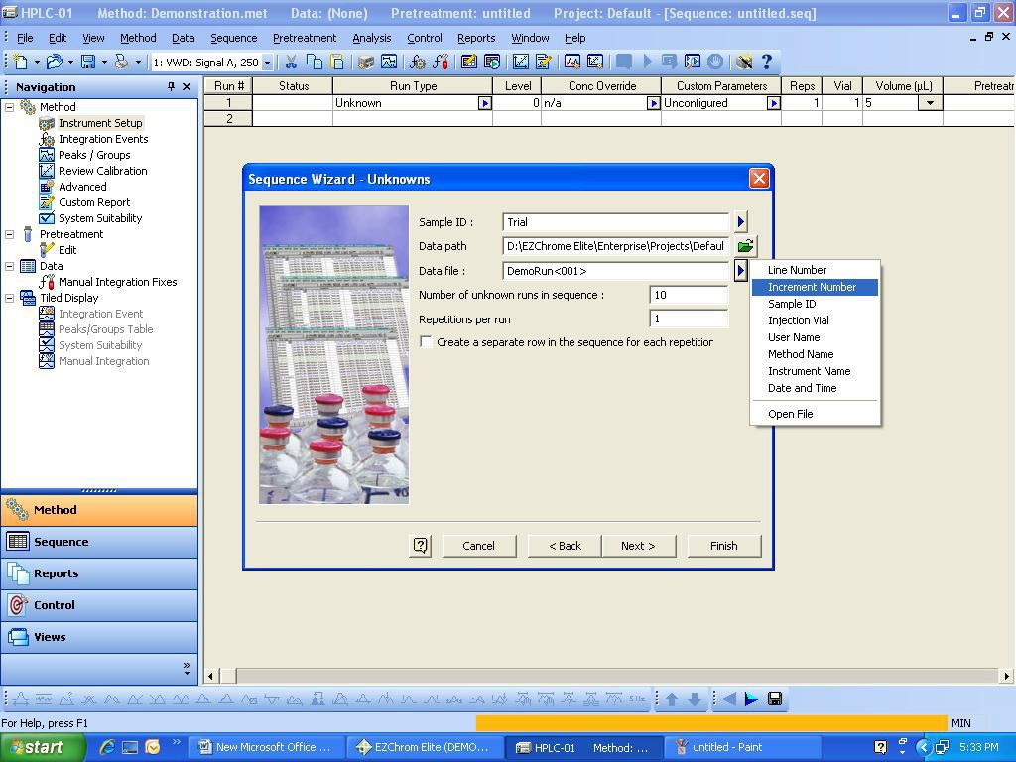

* + 1. The below screen will appear. Browse and select the running Result name by clicking on  the running sequence name will come automatically. After this, just click on Submit and this will run the added lines in the sequence and the data will be saved in the running Result Set.

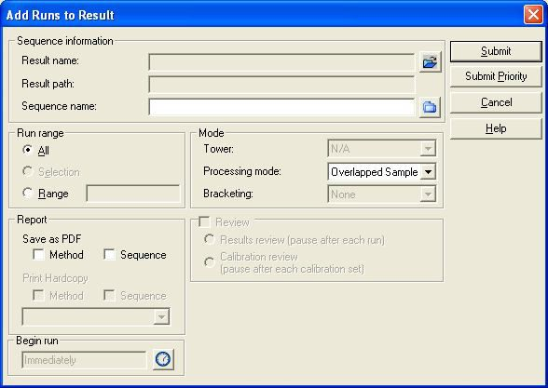

* + 1. After completing the single run the below Results Review Mode screen will appear. In this mode you cannot change or edit the instrument parameter like flow etc. So to access the instrument parameters, click control -> Monitor HPLC.

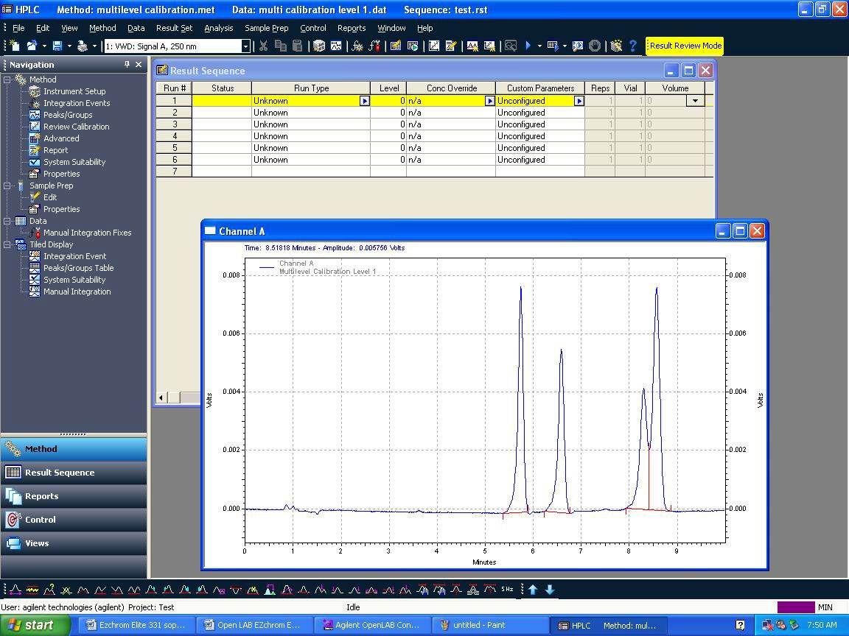

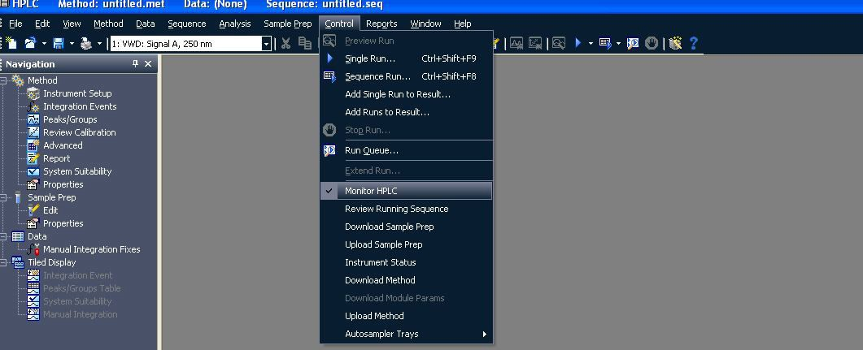

* 1. **How to access acquired data integrate data, assign peak name, process sequence:**
     1. In the Control Panel -> Select Instrument -> select the project -> click on Launch Offline.

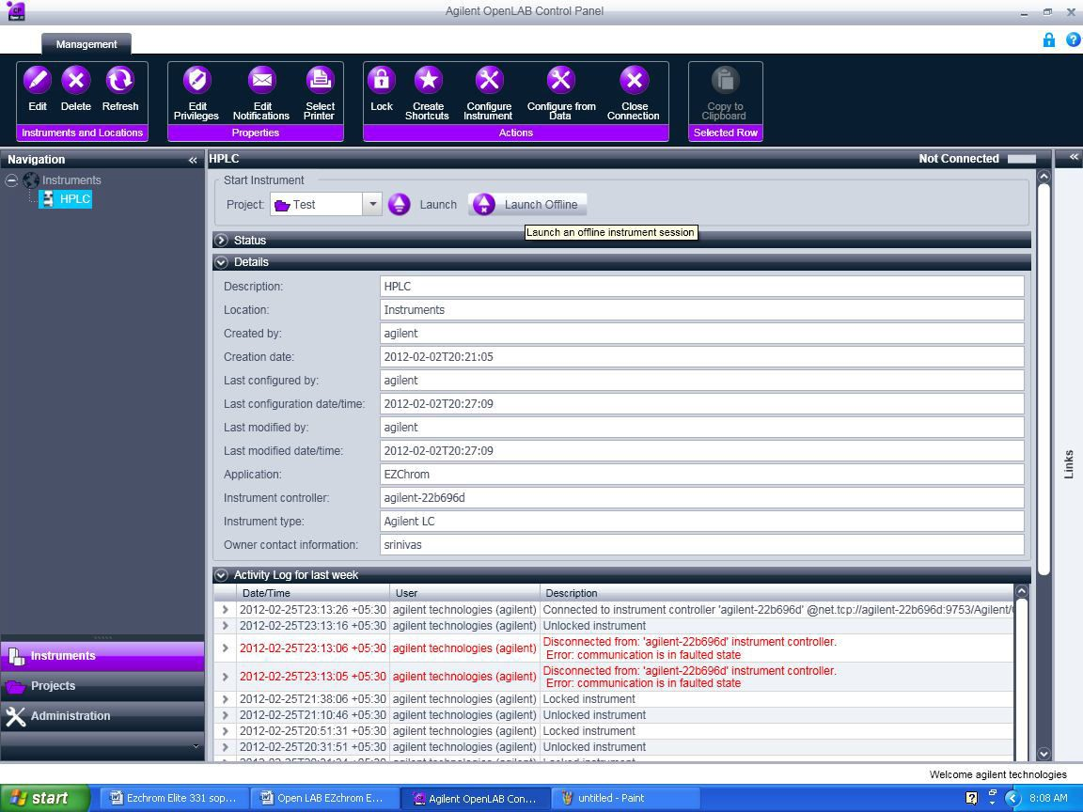

* + 1. The below screen will appear and close the instrument Wizard.

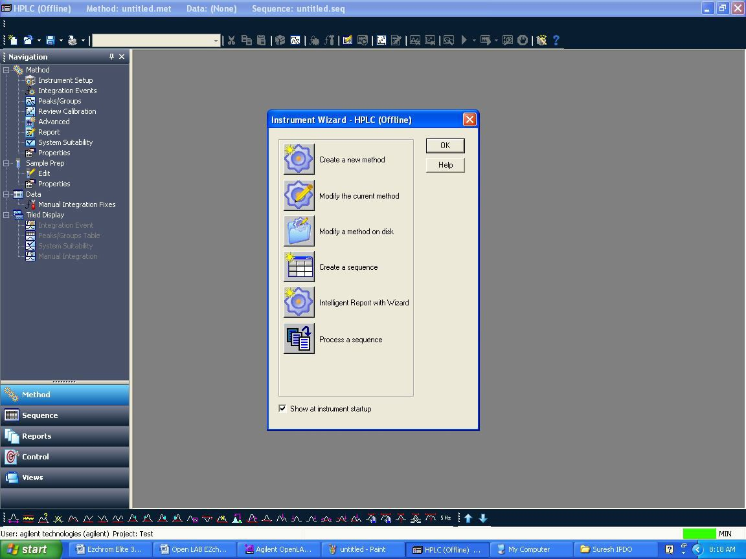

* + 1. Click File -> Open -> Result Set…

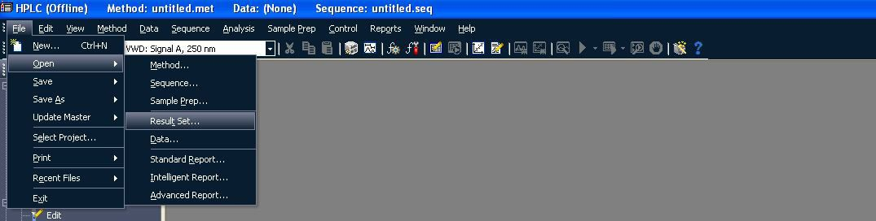

* + 1. The below window will appear and select the required Result Set and click on Open

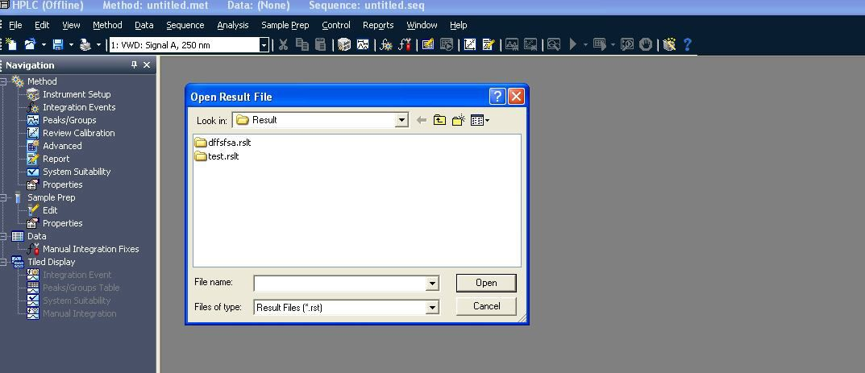

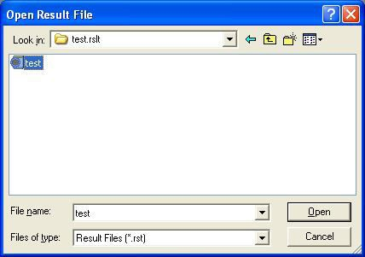

* + 1. The below screen will appear once you click Open. The Result Set will be opened along the Method.

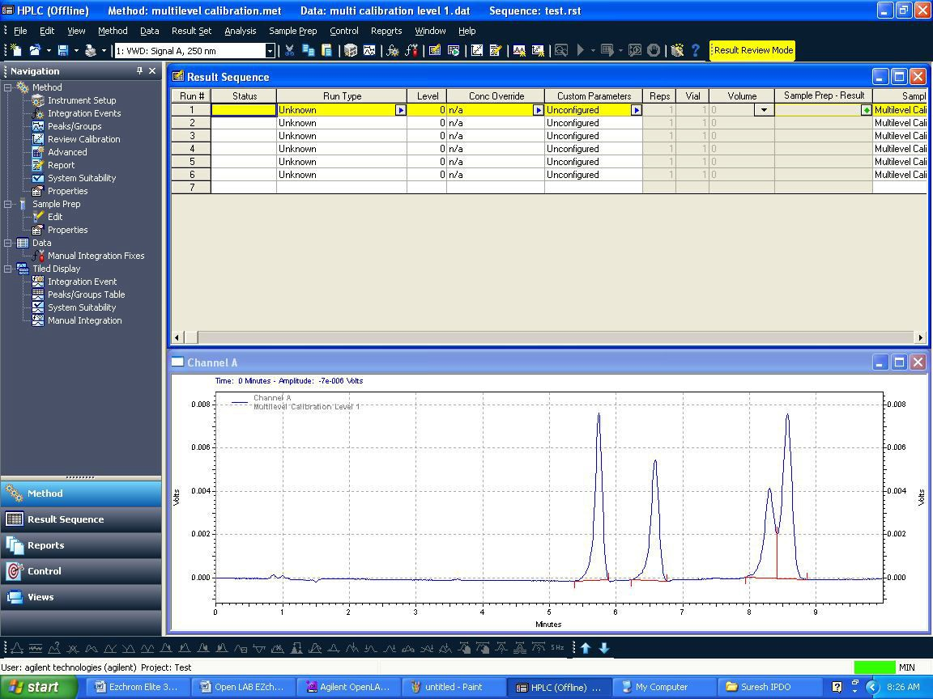

* + 1. To open a data just right click on any line and click on Select Record it will open the data file OR just double click on any line it will open the data file.

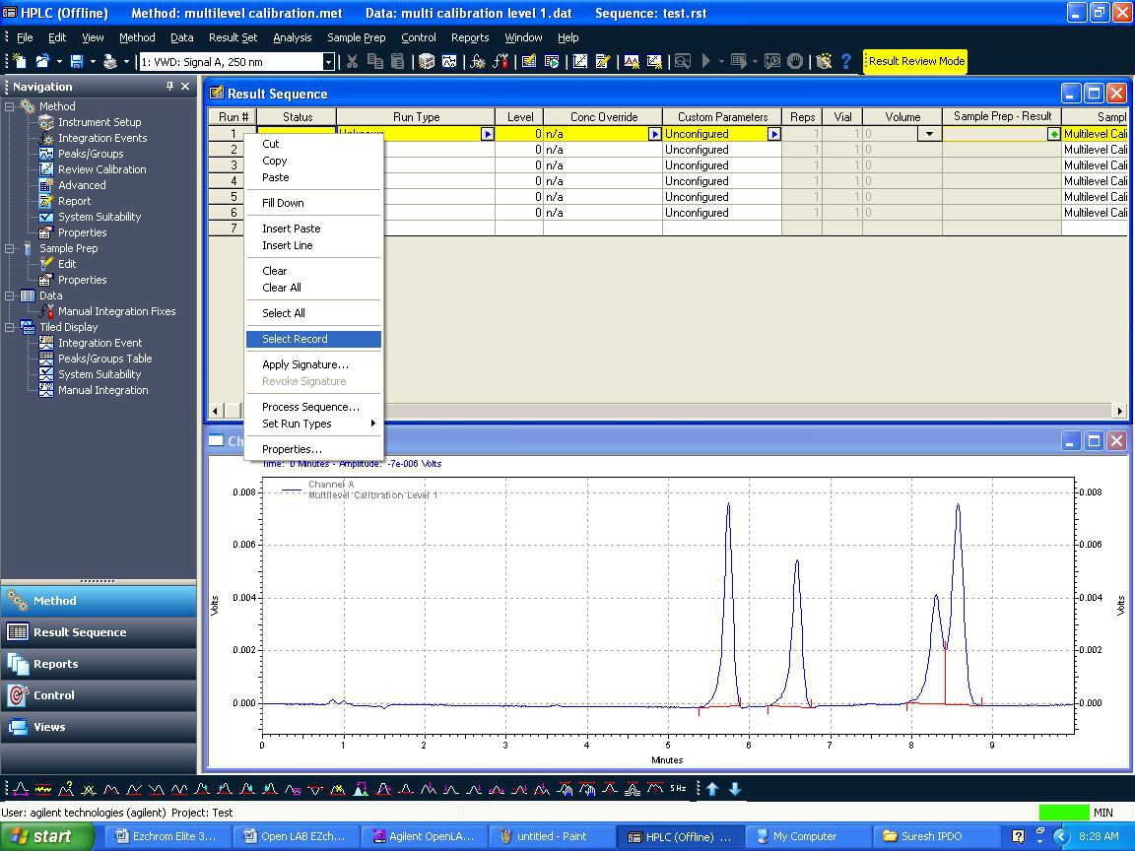

* + 1. To integrate chromatogram, integration events are available.
    2. By right click on chromatogram →Graphical Programming →list will be displayed, from that you can use different integration events like integration off, valley to valley etc.

**OR**

* + 1. You can integrate chromatogram using graphical tools i.e. available at the bottom in the same window.

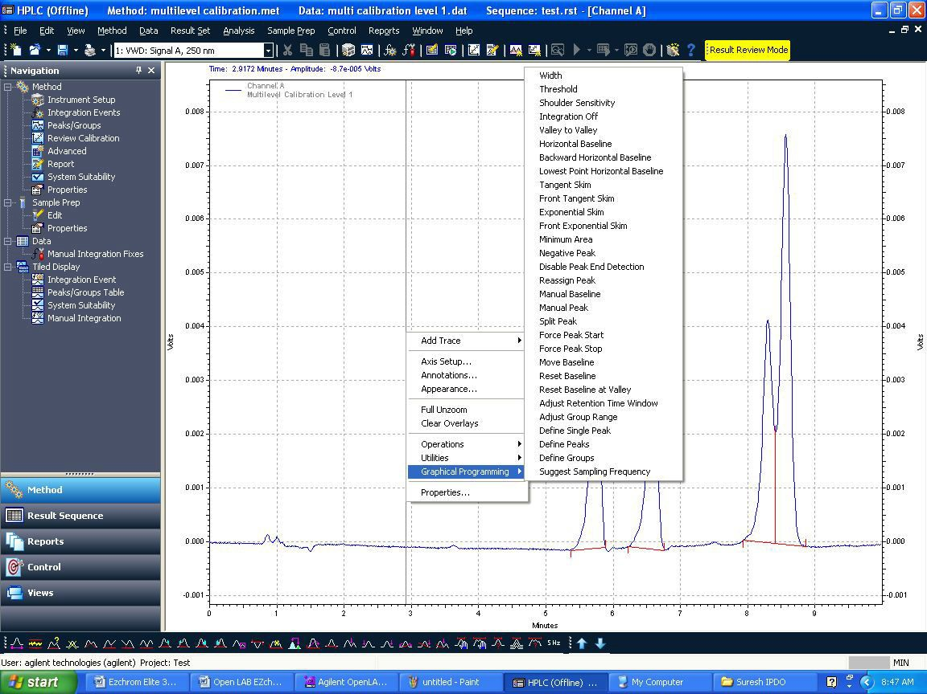

* + 1. If you integrate by using graphical tool, the below screen will appear with integration parameter and in the same window you will be asked to select two options,
    2. Option-1: “Add event to Method (all data)”
    3. Option-2: “Applicable for all the data files.
    4. And if you select Option-2, only the particular the data which is open will be integrated. Add event to the data file only”.
    5. Here if you select Option-1, the events will be added to method.

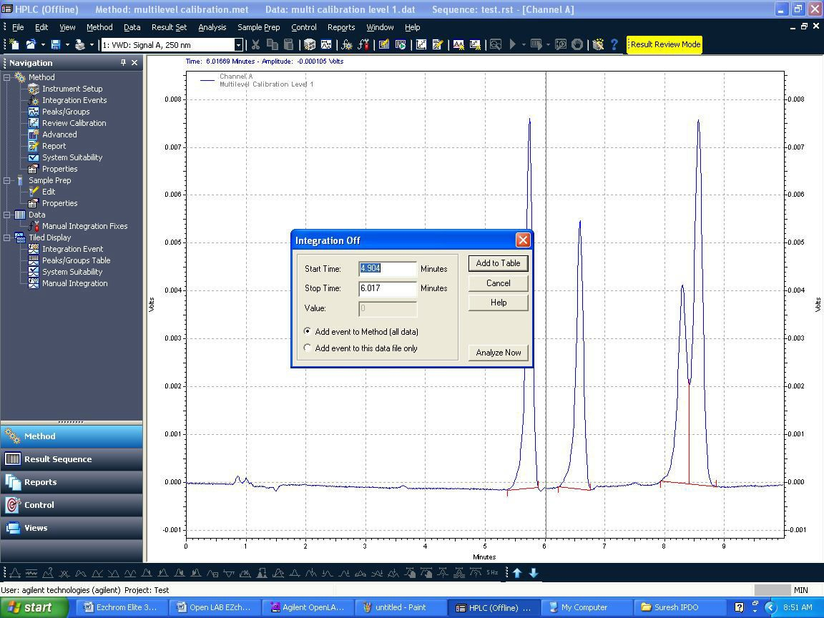

* 1. **Calibration:**
  2. **Calibration Schedule : Every 4 months**

| **S.No** | **Name of the Test** | **Acceptance criteria** |
| --- | --- | --- |
| 1 | Calibration of Pump | |
| Flow accuracy | |
| 1) For flow 0.50 mL/min | Between 0.49 mL and 0.51 mL |
| 2) For flow 1.00 mL/min | Between 0.98 mL and 1.02 mL |
| 3) For flow 2.00 mL/min | Between 1.96 mL and 2.04 mL |
| 2 | Gradient accuracy | 1. At B concentration 10% level actual concentration should be between 9.0% and 11.0%. 2. At B concentration 50% level actual concentration should be between 49.0% and 51.0% 3. At B concentration 90% level actual concentration should be between 89.0% and 91.0%. |
| 3 | System precision and carry over | |
|  | %RSD of Retention time | Not more than 1.0% |
| %RSD of Caffeine Area | Not more than 2.0% |
| Carry over Check | Not more than 5.0% |
| 4 | Detector Linearity | |
|  | Correlation Coefficient | Not less than 0.999 |
| 5 | Wavelength accuracy |  |
|  | First Maximum Peak Area | 205 ± 2 nm |
| Minimum Peak Area | 244 ± 2 nm |
| Second Maximum Peak Area | 271 ± 2 nm |
| 6 | Injector Linearity for Auto sampler | |
|  | Correlation Coefficient | Not less than 0.999 |
| 7 | Injection Volume Accuracy | ± 1.0µL |
| 8 | Column Oven temperature | |
|  | 25°C | ± 2°C |
|  | 40°C | ± 2°C |
|  | 50°C | ± 2°C |
|  | 60°C | ± 2°C |
|  | 70°C | ± 2°C |

* 1. **Calibration of Pump :** 
     1. **Flow Rate Calibration:**
        1. Ensure that the solvent reservoir contains sufficient HPLC water and suspend the suction filter in It so that it dips in water.
        2. Before starting the calibration purge the system with water to remove air bubbles from the flow line.
        3. Install the restrictor capillary /union and allow about 15 minute’s equilibration the system with Water at the flow rate 1.0 ml /min with equal mixing A, B, C &D channels
        4. Place a previously weighed 10 ml volumetric flask to receive the water coming out of the system.
        5. Set the flow collects the water from the column inlet exactly for 2min as measured by a stop watch and weigh the volumetric flask.
        6. Take two readings and note down the weights of water collected (Annexure-1)
        7. Repeat the operation for flow at 1.0ml/min for 10 min, and at 2.0 ml/min for 5min record the Observations.
        8. Calculate actual flow and RSD for duplicate measurement for each flow rate

$$Actual flow=\frac{Collected wate weight}{Colleted time in\min{×0.99602}}$$

*density of water at 25ºC is 0.99602gr

Reference IP-2007 of Volumne-1 Page 165

**Acceptance Criteria :**

|  |  |
| --- | --- |
| **Set flow ml/min** | **Acceptance criteria** |
| 0.50 | 0.49-0.51 |
| 1.0 | 0.98-1.02 |
| 2.00 | 1.96-2.04 |

**5.12.2 Gradient accuracy test:**

**Chromatographic Condition:**

|  |  |  |
| --- | --- | --- |
| Column | **:** | Restriction Capillary |
| Detector wavelength | **:** | 254nm |
| Injection volume | **:** | 20 µl |
| Flow rate | **:** | 2.0ml/minute |
| Runtime | **:** | 30 minutes |
| Mobile Phase | **:** | Mobile Phase-A: Analytical water  Mobile Phase-B:0.3% v/v acetone in filtered analytical water (3ml of acetone in 1000ml of water) |

**Gradient Program:**

| **Time (min)** | **Mobile phase B percentage** |
| --- | --- |
| 0.01 | 0 |
| 2.00 | 0 |
| 2.01 | 10 |
| 8.00 | 10 |
| 8.01 | 50 |
| 13.00 | 50 |
| 13.01 | 90 |
| 18.00 | 90 |
| 18.01 | 100 |
| 23.00 | 100 |
| 23.01 | 0 |
| 30.00 | 0 |

* **Procedure:**

Open the drain valves and purge the flow lines of both pumps. Equilibrate the column with initial concentration with above mentioned conditions and wait until the baseline is stable Adjust the baseline level to fit the full Scale of the integrator. Inject exactly 20 µL of mobile phase A and start the time program for gradient accuracy test.

Determine the signal level at 0% (B Con),10% (B Con), 50% (B Con), 90% (B Con) and 100% (B Con)

Calculate the actual B concentration level at 10% (B Con), 50% (B Con), 90% (B Con) Using 0% (B Con) and 100% (B Con).

* **Calculation:**

Calculate the actual B concentration level at 10**%**

$$=\frac{ B concentration level at 10\% - B concentration level at 0\% x 100}{B concentration level at 100\% - B concentration level at 0\%}$$

Similarly calculate the actual B concentration level at 50% (B Con) and 90% (B Con) Follow the Procedure exactly using C&D channels instead of A&B.

* **Acceptance *Criteria:***

**For pump A&B**

At B concentration 10 %level actual concentration should be between 9.0% and 11.0%.

At B concentration 50% level actual concentration should be between 49.0% and 51.0%.

At B concentration 90% level actual concentration should be between 89.0% and 91.0%.

**For pump C&D**

At D concentration 10% level actual concentration should be between 9.0% and 11.0%.

At D concentration 50% level actual concentration should be between 49.0% and 51.0

At D concentration 90% level actual concentration should be between 89.0% and 91.0%.

* + 1. **System Precision & Carry over:**
       1. Prepare the required standard solution and set the chromatographic condition as mention below
       2. **Standard preparation**: weigh accurately 100±2mg Caffeine AR in a100 ml volumetric flask, dissolve in 25 ml HPLC Methanol and make up volume with the same.
       3. Transfer 5ml of above solution in another 100 ml volumetric flask and make up the volume with methanol (50ppm )
       4. HPLC Conditions

|  |  |
| --- | --- |
| Column | Restrictor capillary 2m x 0.12 mm ID |
| Mobile Phase | Methanol :water (70:30) |
| Flow rate ml/min | 1ml/min |
| Wave length | 272 nm |
| Run time | 5minutes |

* + - 1. Apply the sequence of blank, six replicate injections with 50 ppm Caffeine solution in methanol and blank After complete the runs measure peak retention time and area Last blank in sequence shall be used to measure carryover of auto sampler
 $$\%Carry over=\frac{Area at the RT of caffeine peak in blank}{Area of sixth standard injection}×100$$

     2. Calculate the % RSD for each and record the observation in annexure-1

|  |  |
| --- | --- |
| **% RSD for retention time** | **NMT 1.0%** |
| **% RSD for Area** | **NMT 2.0%** |
| **%Carry over** | **NMT 5.0%** |

* + 1. **Detector linearity:**
       1. **Standard preparation :**

**Solution A:** weigh accurately 100±2mg Caffeine AR in a100 ml volumetric flask, dissolve in 25 ml HPLC Methanol and make up volume with the same.

**50ppm**: Pipette 5ml of solution –A in 100 ml volumetric flask and make up with methanol.

**25ppm**: Pipette 2.5ml of solution –A in 100 ml volumetric flask and make up with methanol.

**10ppm**: Pipette 10ml of 50ppm solution in 50 ml volumetric flask and make up with methanol.

**5ppm**: Pipette 5ml of 50ppm solution in 50 ml volumetric flask and make up with methanol.

**1ppm**: Pipette 1ml of 50ppm solution in 50 ml volumetric flask and make up with methanol

* + - 1. Set the chromatographic condition as mentioned below.

|  |  |
| --- | --- |
| Column | Restrictor capillary 2m x 0.12 mm ID |
| Mobile Phase | Methanol :water (70:30) |
| Flow rate ml/min | 1ml/min |
| Wave length | 272nm |
| Run time | 5 minutes |

* + - 1. Inject the solution in sequence of 1 ppm, 5ppm, 10ppm, 25 ppm and 50ppm
      2. After the completion of each run measure are of caffeine peak and record the observation in annexure-1. Calculate the co-relation coefficient of the peak areas.

|  |  |
| --- | --- |
| **Acceptance criteria:** | |
| **Correlation coefficient** | **NLT 0.999** |

* + 1. **Wave length Accuracy :**
       1. UV wave length Accuracy checks using Maximum & minimum absorbance wave length of caffeine obtain with 50 ppm solution.
       2. Solution-A: weigh accurately 100±2mg Caffeine AR in a100 ml volumetric flask ,dissolve in 25 ml HPLC Methanol and make up volume with the same.
       3. 50ppm: Pipette 5ml of solution –A in 100 ml volumetric flask and make up with methanol.
       4. Chromatographic condition:

|  |  |
| --- | --- |
| Column | Restrictor capillary 2m x 0.12 mm ID |
| Mobile Phase | Methanol :water (70:30) |
| Flow rate ml/min | 1ml/min |
| Wave length | 200-210,240-250, and 268-278nm |
| Run time | 5minutes |

* + - 1. Increase the wave length setting from 200-210,240-250 and 268-278nm 1 nm increments and record chromatogram after 1 nm increment rise in annexure-1

|  |  |
| --- | --- |
| **Acceptance criteria:** | |
| **Maximum absorbance** | 271±2nm and 205 ±2nm |
| **Minimum absorbance** | 244±2nm |

* + 1. **Injector linearity for Auto sampler:**
       1. **Standards Preparation:**
          1. **Solution A:** weigh accurately 100±2mg Caffeine AR in a100 ml volumetric flask, dissolve in 25 ml HPLC Methanol and make up volume with the same.
          2. **50ppm**: Pipette 5ml of solution –A in 100 ml volumetric flask and make up with methanol.
          3. **10ppm**: Pipette 10ml of 50 ppm solution in 100 ml volumetric flask and make up with methanol.
       2. **Set the chromatographic condition as mentioned below:**

Inject 10ppm caffeine solution 5, 10, 20, 50, and 100 micro liter and record the chromatograms.

Calculate correlation coefficient of conc. Vs peak areas

|  |  |
| --- | --- |
| Column | Restrictor capillary 2m x 0.12 mm ID |
| Mobile Phase | Methanol :water (70:30) |
| Flow rate ml/min | 1ml/min |
| Wave length | 254nm |
| Run time | 5minutes |

|  |  |
| --- | --- |
| **Acceptance criteria:** | |
| correlation coefficient | NLT 0.999 |

* + 1. **Injection Volume Accuracy :**

Fill the vial with HPLC water note down the weight and place in the sample tray at vial number 1. Methanol shall be used as above and create a sequence to get 10 injections with 50µL injection volume and run time is 0.1 min and start sequence. After 10 injections remove the vial and weigh again.

Calculate as give below:

$$Volume injected per vail=\frac{Wt of water in gm }{10×0.99602}×1000$$

**Acceptance criteria: ±1.0µl**

* + 1. **Column Oven Temperature :**

The temperature of the column oven is to be determined using a calibrated thermometer at 25ºC,40ºC,50ºC,60ºC and 700C either by internally or externally**.**

**Acceptance Criteria:**

Not more than ±2ºC for set temperature.

* 1. **Preventive maintenance**:
     1. Whenever system is under break-down or preventive maintenance of instrument is required To inform Service Engineer and out the label “Under maintenance’ or ‘Under breakdown’ on it
     2. Preventive maintenance shall be carried out by a trained Service Engineer of Supplier
     3. After completion of service record the fact of replacement of any major part of instrument.
     4. Calibrate the instrument after the maintenance is over.

1. **FORMATS / ANNEXURE(S):**
   1. Instrument Usage log Book : QC048-FM088
   2. HPLC Calibration Record : QC046-FM077
2. **CHANGE HISTORY:**

| **Revision No.** | **Effective Date** | **Details of Revision** | **Ref CCF No.** |
| --- | --- | --- | --- |
| 00 | 29.08.2016 | New SOP introduced | -- |
| 01 | 01.01.2017 | SOP format changed make to in line with SOP-QA-001-04 | QC-CRF-025/16 |
| 02 | 26.04.2017 | 1. SOP format changed make to in line with SOP-QA-001-05. 2. In procedure 5.6.5 point enabling of audit trail while creating project is optional. Make it mandatory while creating project. | CCF/GEN/17014 |
| 03 | 11.09.2017 | 1. Logo incorporated  2. Inserted injection volume accuracy test and injection linearity test in calibration procedure. | CCF/GEN/17024 |